Computing Fundamentals OEL 1

(FALL 2022)

Question No 1: From Given data find the overall average speed of all rides that satisfy the following criteria:

* The Type is wood
* The Design is Sit Down
* The Amusement Park has word “Park” in title

also compute the final results in the form of suitable visualization chart.

Solution:

Given data:

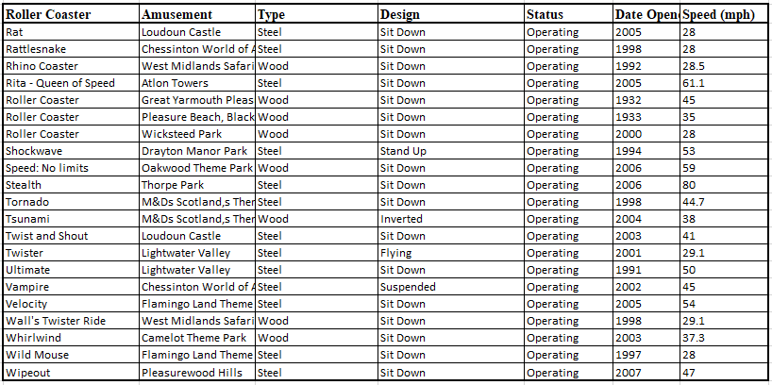

Result:

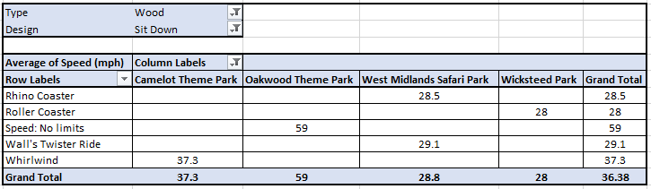

Question No 2: Create a student timetable and show it on a Web page.

Input:

<html>

    <table border="4">

        <tr>

        <th colspan="6"><center>Time Table</center></th>

        </tr>

        <tr>

        <th rowspan="7">Hours</th>

        </tr>

        <tr>

        <th>Mon</th>

        <th>Tue</th>

        <th>Wed</th>

        <th>Thu</th>

        <th>Fri</th>

        </tr>

        <tr>

            <td>Science</td>

            <td>Maths</td>

            <td>Science</td>

            <td>Maths</td>

            <td>Arts</td>

        </tr>

        <tr>

            <td>Social</td>

            <td>History</td>

            <td>English</td>

            <td>Social</td>

            <td>Sports</td>

        </tr>

        <tr>

            <th colspan="5"><center>Lunch</center></th>

        </tr>

        <tr>

            <td>Science</td>

            <td>Maths</td>

            <td>Science</td>

            <td>Maths</td>

            <td rowspan="2">Preject</td>

        </tr>

        <tr>

            <td>Social</td>

            <td>History</td>

            <td>English</td>

            <td>Social</td>

        </tr>

    </table>

</html>

Output:

